

Individual Assessment Coversheet

To be attached to the front of the assessment.

Tygervalley

|  |  |
| --- | --- |
| Campus: | _____________________________________________________  Information Technology |
| Faculty: | _____________________________________________________ |
| Module Code: | _____________________________________________________  1  ITCEA-B12 |
| Group: | _____________________________________________________  William Olivier |
| Lecturer’s Name: | _____________________________________________________  Ryan Kok |
| Student Full Name: | _____________________________________________________  QB8J66C71 |
| Student Number: | _____________________________________________________ |
| eVision Number: | _____________________________________________________ |

|  |  |  |
| --- | --- | --- |
| Indicate | Yes | No |
| Plagiarism report attached |  |  |

Declaration:

I declare that this assessment is my own original work except for source material explicitly acknowledged. I also declare that this assessment or any other of my original work related to it has not been previously, or is not being simultaneously, submitted for this or any other course. I also acknowledge that I am aware of the Institution’s policy and regulations on honesty in academic work as set out in the Eduvos Conditions of Enrolment, and of the disciplinary guidelines applicable to breaches of such policy and regulations.

|  |  |
| --- | --- |
| Signature: Ryan Kok | Date: 14/04/2023 |

Eduvos (Pty) Ltd. (formerly Pearson Institute of Higher Education) is registered with the Department of Higher Education and Training as a private higher education institution under the Higher Education Act, 101, of 1997. Registration Certificate number: 2001/HE07/008

Lecturer’s Comments:

|  |  |  |
| --- | --- | --- |
| Marks Awarded: |  | % |
|  |  |  |
| Signature | Date | |

Individual Assessment Coversheet 2023 | V1.0 Page 2 of 2

Contents

Question 2 4

References For This Question: 9

Full Bibliography: 10

# Question 2

#### Store Website:

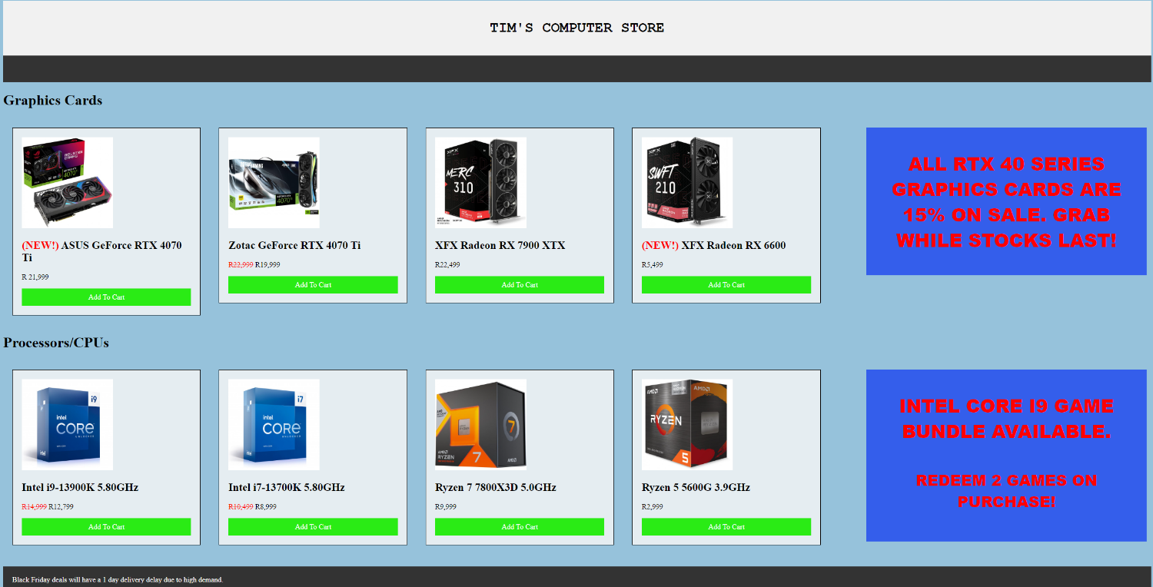

[Prices and images taken from (wootware, 2023)]

#### Store Code:

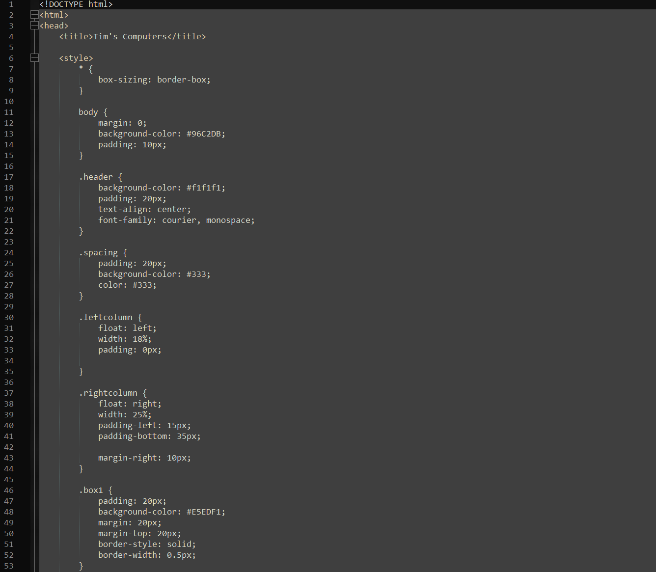

[CSS Box Model (Gupta, 2023)]

[Colour Scheme Samples (B., 2022)]

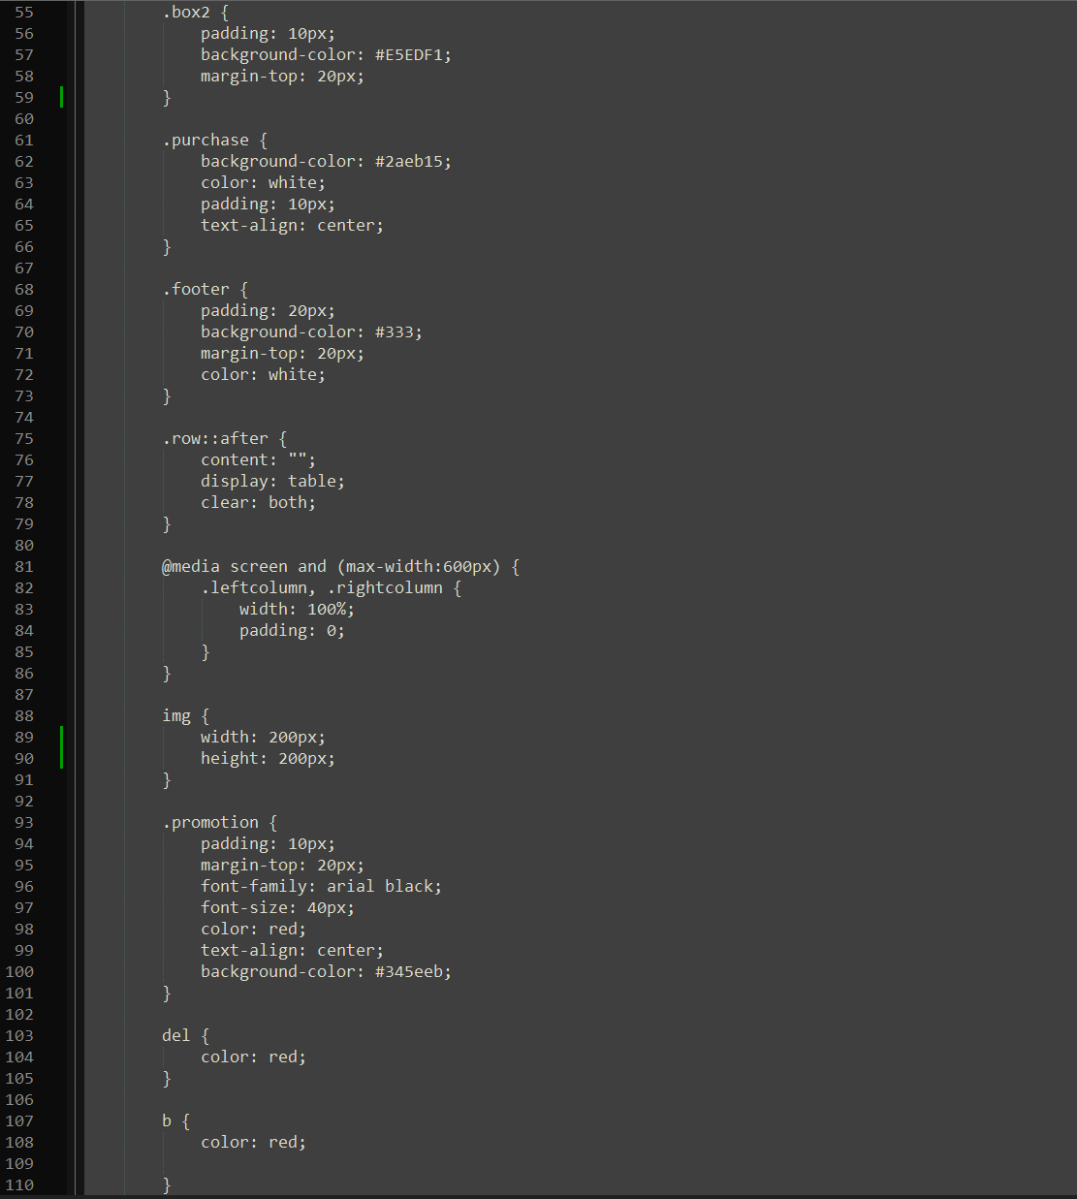

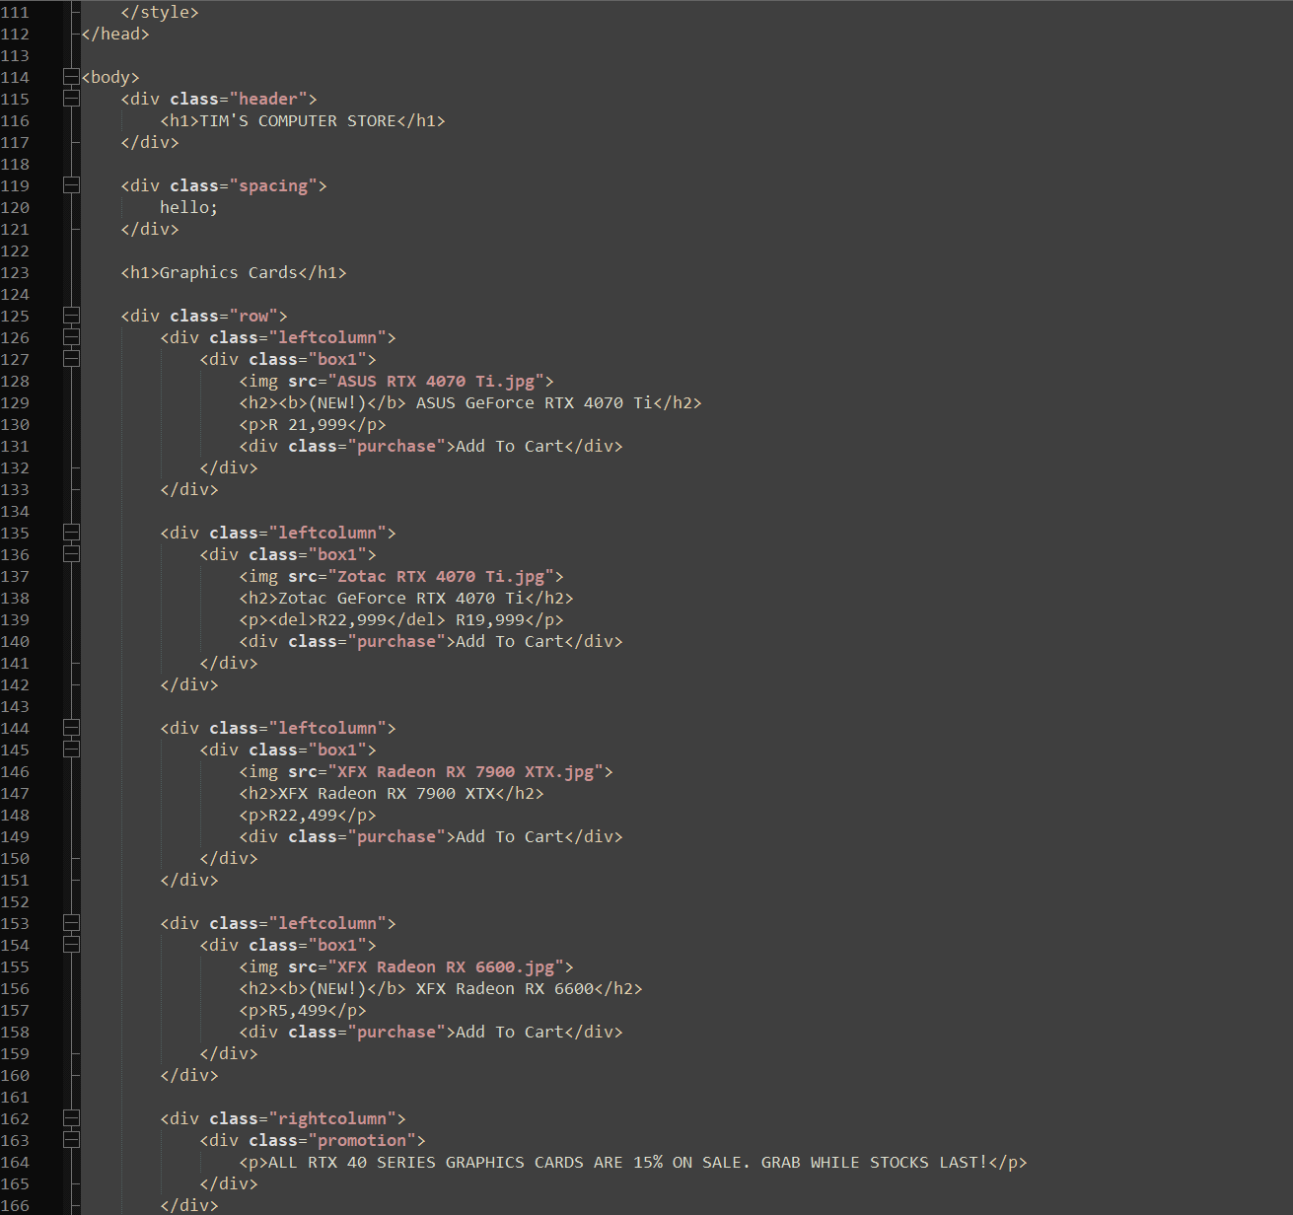

[HTML img Tag (tutorialspoint, 2023)]

[HTML Bold Text (Fitzgerald, 2023)]

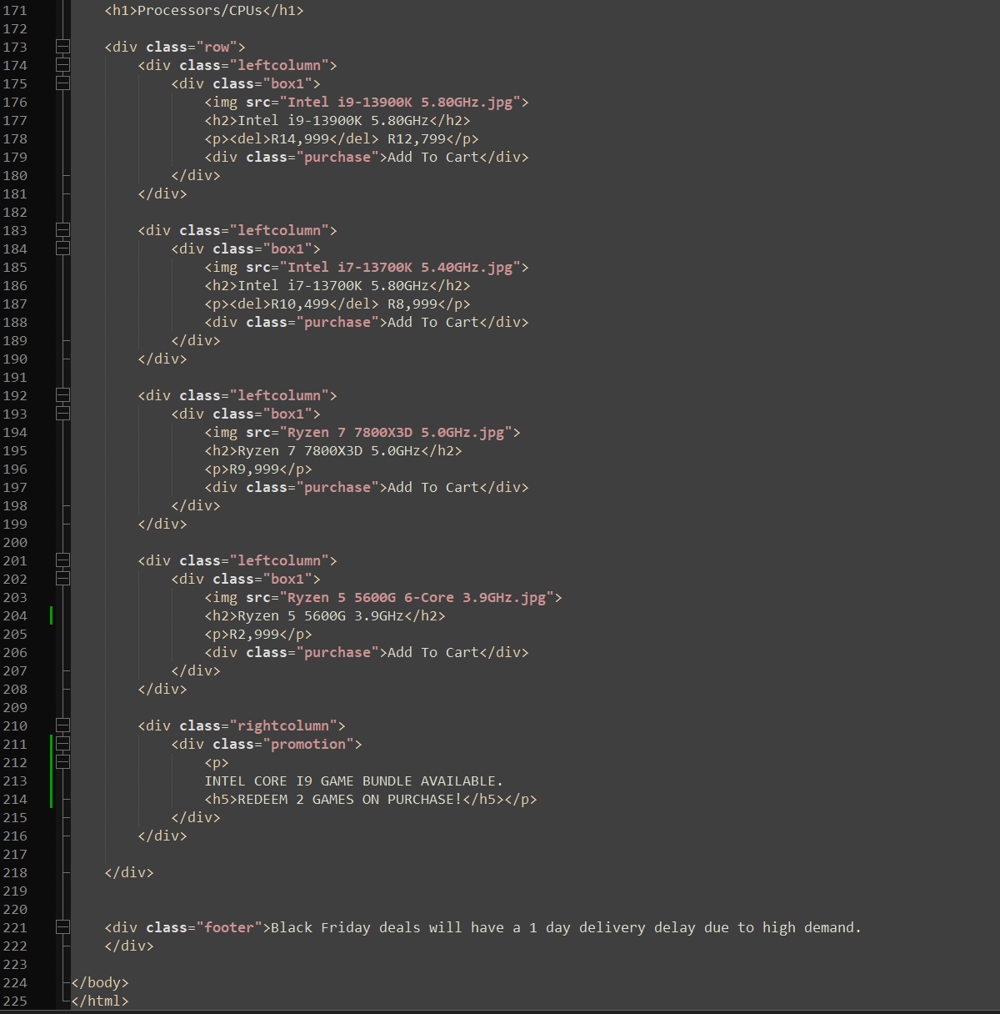

# References For This Question:

B., A., 2022. *The 30 Best Website Color Schemes to Make Your Website More Compelling.* [Online]   
Available at: https://www.hostinger.com/tutorials/website-color-schemes  
[Accessed 9 April 2023].

Fitzgerald, A., 2023. *How to Bold, Italicize & Format Text in HTML.* [Online]   
Available at: https://blog.hubspot.com/website/how-to-bold-in-html  
[Accessed 11 April 2023].

Gupta, A., 2023. *Learn CSS Box Model and its Properties with Examples.* [Online]   
Available at: https://www.simplilearn.com/tutorials/css-tutorial/css-box-model  
[Accessed 10 April 2023].

tutorialspoint, 2023. *HTML - <img> Tag.* [Online]   
Available at: https://www.tutorialspoint.com/html/html_img_tag.htm  
[Accessed 10 April 2023].

wootware, 2023. *Graphics Cards on Sale.* [Online]   
Available at: https://www.wootware.co.za/computer-hardware/video-cards-video-devices  
[Accessed 11 April 2023].

# Full Bibliography:

B., A., 2022. *The 30 Best Website Color Schemes to Make Your Website More Compelling.* [Online]   
Available at: https://www.hostinger.com/tutorials/website-color-schemes  
[Accessed 9 April 2023].

Chibana, N., 2023. *50 Gorgeous Color Schemes From Award-Winning Websites.* [Online]   
Available at: https://visme.co/blog/website-color-schemes/  
[Accessed 7 April 2023].

CodesDope, 2017. *Adding Outline to Text Using CSS.* [Online]   
Available at: https://www.codesdope.com/blog/article/adding-outline-to-text-using-css/  
[Accessed 9 April 2023].

dofactory, 2023. *HTML <input> type="checkbox" Attribute.* [Online]   
Available at: https://www.dofactory.com/html/input/checkbox  
[Accessed 9 April 2023].

Fink, G., 2011. *HTML5 Web Notifications.* [Online]   
Available at: https://www.codeproject.com/Articles/233554/HTML-Web-Notifications  
[Accessed 9 April 2023].

Fitzgerald, A., 2023. *How to Bold, Italicize & Format Text in HTML.* [Online]   
Available at: https://blog.hubspot.com/website/how-to-bold-in-html  
[Accessed 11 April 2023].

GeeksForGeeks, 2021. *How to pop an alert message box using PHP ? - GeeksforGeeks.* [Online]   
Available at: https://www.geeksforgeeks.org/how-to-pop-an-alert-message-box-using-php/  
[Accessed 9 April 2023].

Gupta, A., 2023. *Learn CSS Box Model and its Properties with Examples.* [Online]   
Available at: https://www.simplilearn.com/tutorials/css-tutorial/css-box-model  
[Accessed 10 April 2023].

Patel, V., 2011. *How To Reset MySQL Autoincrement Column.* [Online]   
Available at: https://www.viralpatel.net/reseting-mysql-autoincrement-column/  
[Accessed 8 April 2023].

PHPTutorial, 2023. *PHP Form.* [Online]   
Available at: https://www.phptutorial.net/php-tutorial/php-form/  
[Accessed 8 April 2023].

Tutorial Republic, 2020. *Using Prepared Statements in MySQL with PHP - Tutorial Republic.* [Online]   
Available at: https://www.tutorialrepublic.com/php-tutorial/php-mysql-prepared-statements.php  
[Accessed 10 April 2023].

tutorialspoint, 2023. *HTML - <img> Tag.* [Online]   
Available at: https://www.tutorialspoint.com/html/html_img_tag.htm  
[Accessed 10 April 2023].

w3schools, 2023. *PHP Form Validation.* [Online]   
Available at: https://www.w3schools.com/php/php_form_validation.asp  
[Accessed 9 April 2023].

wootware, 2023. *Graphics Cards on Sale.* [Online]   
Available at: https://www.wootware.co.za/computer-hardware/video-cards-video-devices  
[Accessed 11 April 2023].

Zastrow, P., 2022. *How To Style Common Form Elements with CSS | DigitalOcean.* [Online]   
Available at: https://www.digitalocean.com/community/tutorials/how-to-style-common-form-elements-with-css  
[Accessed 9 April 2023].